## WEEK – 7 REACT ASSIGNMENT

**ASSIGNMENT – 9**

**Creating an React application :**

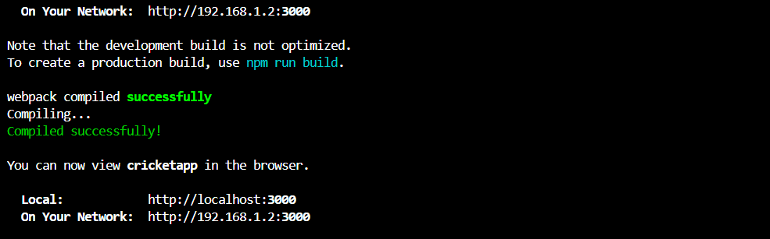

**Working Directory:**

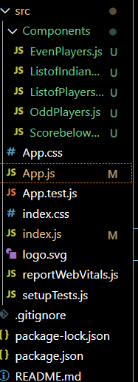

**App.js Code**

*import React from 'react';*

*import ListofPlayers from './Components/ListofPlayers';*

*import Scorebelow70 from './Components/Scorebelow70';*

*import OddPlayers from './Components/OddPlayers';*

*import EvenPlayers from './Components/EvenPlayers';*

*import ListofIndianPlayers from './Components/ListofIndianPlayers';*

*function App() {*

*const flag = false;*

*const players = [*

*{ name: 'Chris gayle', score: 50 },*

*{ name: 'warner', score: 70 },*

*{ name: 'adb villiers', score: 40 },*

*{ name: 'Pollard', score: 61 },*

*{ name: 'James Anderson', score: 61 },*

*{ name: 'Sachin', score: 95 },*

*{ name: 'Dhoni', score: 100 },*

*{ name: 'Virat', score: 104 },*

*{ name: 'Jadeja', score: 64 },*

*{ name: 'Raina', score: 75 },*

*{ name: 'Rohit', score: 80 }*

*];*

*const IndianTeam = ['Sachin1', 'Dhoni2', 'Virat3', 'Rohit4', 'Yuvraj5', 'Raina6'];*

*const IndianPlayers = [*

*'Mr. First Player',*

*'Mr. Second Player',*

*'Mr. Third Player',*

*'Mr. Fourth Player',*

*'Mr. Fifth Player',*

*'Mr. Sixth Player'*

*];*

*if (flag === true) {*

*return (*

*<div>*

*<h1>List of Players</h1>*

*<ListofPlayers players={players} />*

*<hr />*

*<h1>List of Players having Scores Less than 70</h1>*

*<Scorebelow70 players={players} />*

*</div>*

*);*

*} else {*

*return (*

*<div>*

*<div>*

*<h1>Indian Team</h1>*

*<h1>Odd Players</h1>*

*<OddPlayers IndianTeam={IndianTeam} />*

*<hr />*

*<h1>Even Players</h1>*

*<EvenPlayers IndianTeam={IndianTeam} />*

*</div>*

*<hr />*

*<div>*

*<h1>List of Indian Players Merged:</h1>*

*<ListofIndianPlayers IndianPlayers={IndianPlayers} />*

*</div>*

*</div>*

*);*

*}}*

*export default App;*

**Create an Folder Componenets and create the below files**

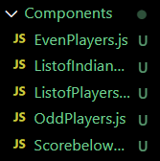

**EvenPlayers.js code**

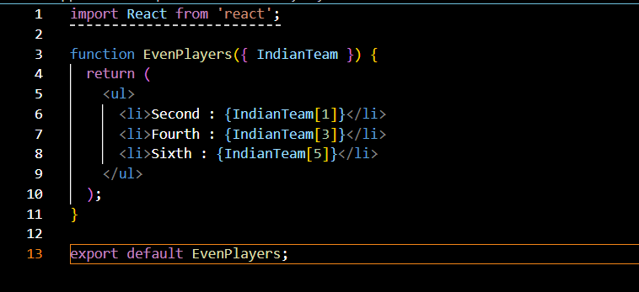

**OddPlayers.js code**

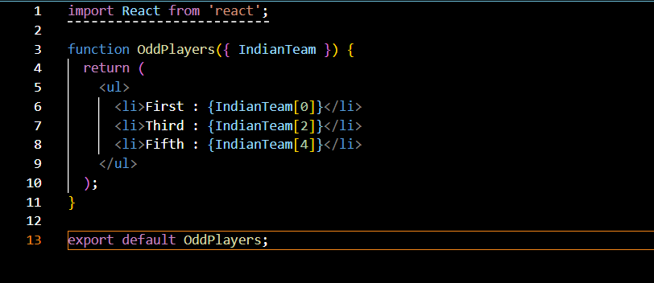

**ListofIndianPlayers.js code**

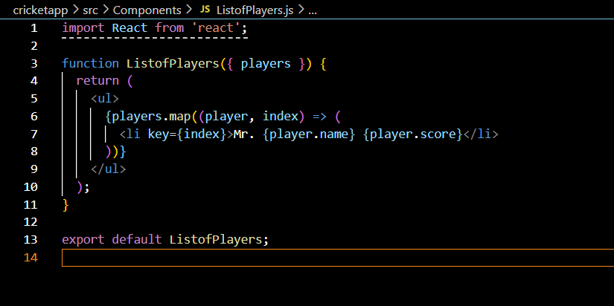

**Scorebelow70.js Code**

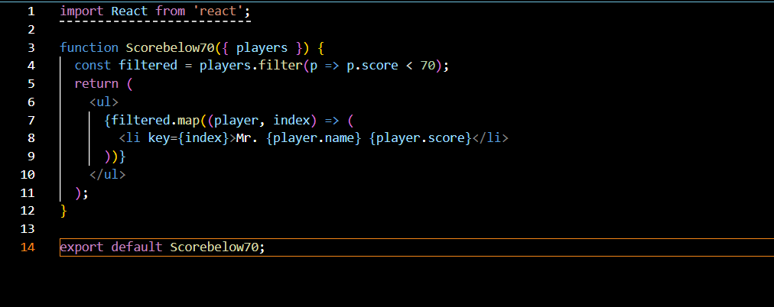

**Output :**

**Toogle = false :**

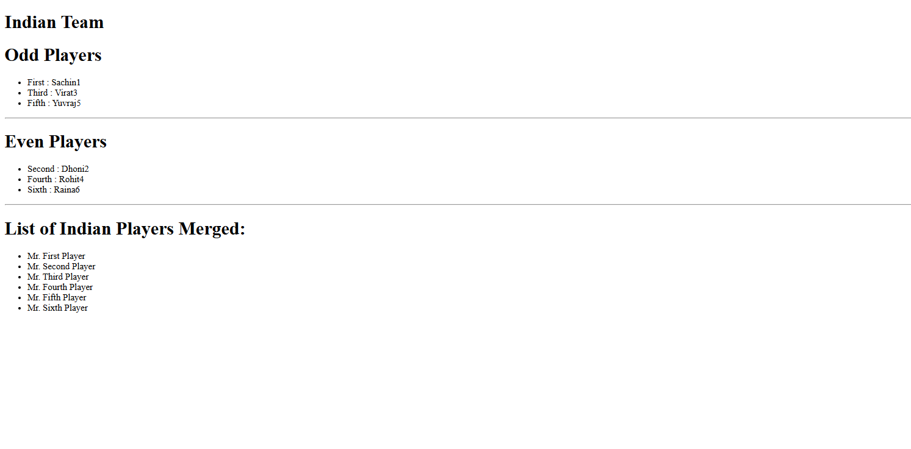

**Toggle = true :**

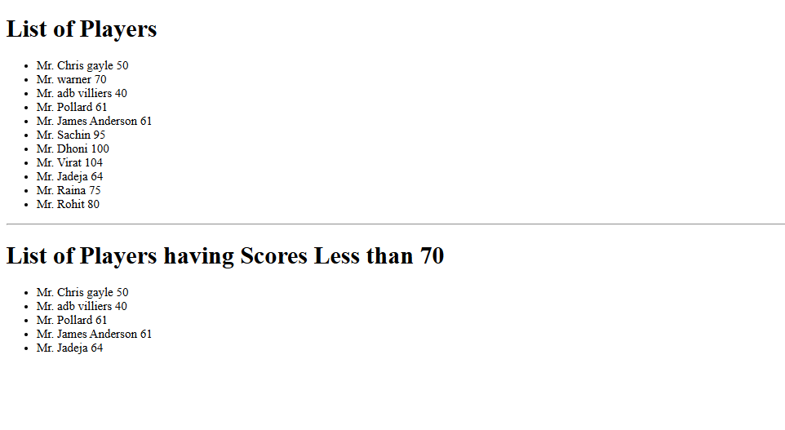

**ASSIGNMENT – 10**

**Create the react App and Working Directory :**

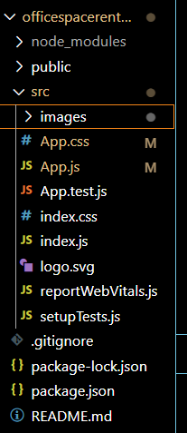

**App.js code :**

*import React from 'react';*

*import './App.css';*

*function App() {*

*const offices = [*

*{*

*name: "Amazon",*

*rent: 50000,*

*address: "Chennai",*

*image: "images/img1.jpeg"*

*},*

*{*

*name: "cognizant",*

*rent: 65000,*

*address: "Bangalore",*

*image: "images/img2.jpg"*

*},*

*{*

*name: "DBS",*

*rent: 58000,*

*address: "Hyderabad",*

*image: "images/img3.jpeg"*

*},*

*{*

*name: "CommerZone",*

*rent: 75000,*

*address: "Mumbai",*

*image: "images/img4.webp"*

*},*

*{*

*name: "Meta",*

*rent: 40000,*

*address: "Delhi",*

*image: "images/img5.jpeg"*

*}*

*];*

*return (*

*<div className="container">*

*<h1>Office Space, at Affordable Range</h1>*

*{offices.map((office, index) => (*

*<div key={index} className="card">*

*<img src={office.image} alt={office.name} />*

*<h2>Name: {office.name}</h2>*

*<p className={office.rent > 60000 ? 'rent-green' : 'rent-red'}>*

*Rent: Rs. {office.rent}*

*</p>*

*<p>Address: {office.address}</p>*

*</div>*

*))}*

*</div>*

*);*

*}*

*export default App;*

**APP.CSS CODE**

**.container {**

**padding: 30px;**

**font-family: Arial, sans-serif;**

**}**

**h1 {**

**font-size: 24px;**

**font-weight: bold;**

**margin-bottom: 20px;**

**}**

**.card {**

**border: 1px solid #ccc;**

**padding: 15px;**

**margin-bottom: 30px;**

**max-width: 350px;**

**border-radius: 8px;**

**box-shadow: 2px 2px 10px #ddd;**

**}**

**.card img {**

**width: 100%;**

**height: auto;**

**margin-bottom: 10px;**

**}**

**.rent-red {**

**color: red;**

**font-weight: bold;**

**}**

**.rent-green {**

**color: green;**

**font-weight: bold;**

**}**

**Output :**

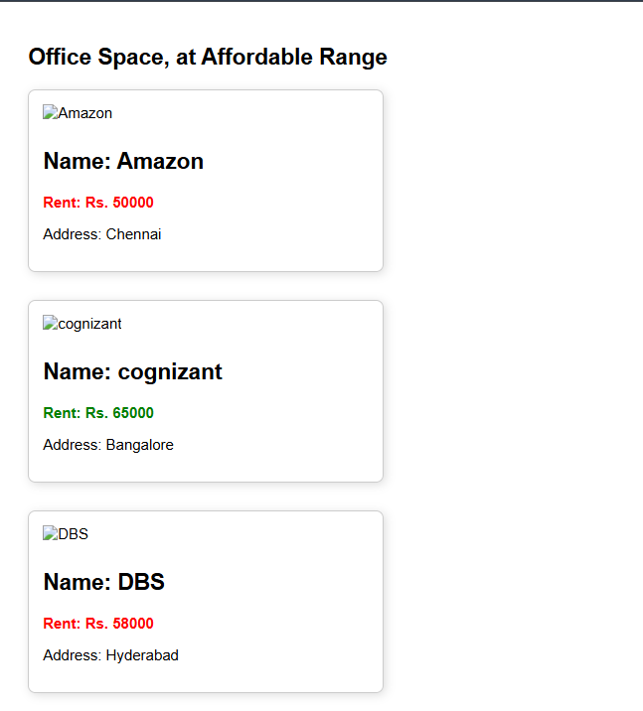

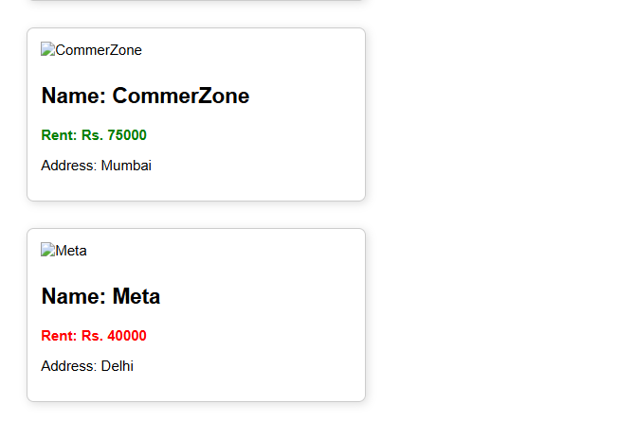

**Assignment – 11**

**Creating the react app**

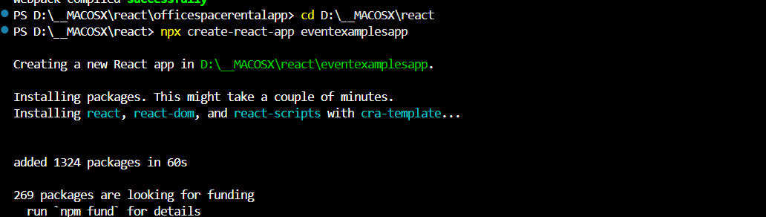

**Working Directory :**

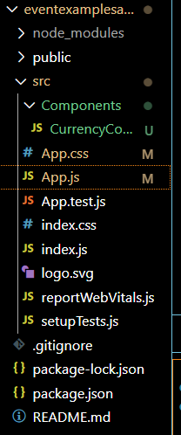

**APP.JS CODE**

*import React, { useState } from 'react';*

*import './App.css';*

*import CurrencyConverter from './Components/CurrencyConverter';*

*function App() {*

*const [count, setCount] = useState(0);*

*const increment = () => {*

*setCount(prev => prev + 1);*

*sayHello();*

*showMessage();*

*};*

*const decrement = () => {*

*setCount(prev => prev - 1);*

*};*

*const sayHello = () => {*

*console.log("Hello!");*

*};*

*const showMessage = () => {*

*console.log("This is a static message after Hello.");*

*};*

*const sayWelcome = (message) => {*

*alert(message);*

*};*

*const onPressHandler = () => {*

*alert("I was clicked");*

*};*

*return (*

*<div className="App">*

*<h1>Event Examples App</h1>*

*<div className="counter-section">*

*<h2>Counter: {count}</h2>*

*<button onClick={increment}>Increment</button>*

*<button onClick={decrement}>Decrement</button>*

*</div>*

*<div className="button-section">*

*<button onClick={() => sayWelcome("Welcome!")}>Say Welcome</button>*

*<button onClick={onPressHandler}>Click on me</button>*

*</div>*

*<CurrencyConverter />*

*</div>*

*);*

*}*

*export default App;*

**APP.CSS CODE :**

*.App {*

*text-align: center;*

*padding: 2rem;*

*font-family: Arial, sans-serif;*

*}*

*.counter-section,*

*.button-section,*

*.currency-converter {*

*margin-bottom: 2rem;*

*}*

*button {*

*margin: 5px;*

*padding: 8px 12px;*

*}*

*input {*

*margin-left: 10px;*

*padding: 5px;*

*}*

*h2 {*

*color: green;*

*}*

**COMPONENTS/CURRENCYCONVERTER.JS CODE**

*import React, { useState } from 'react';*

*function CurrencyConverter() {*

*const [rupees, setRupees] = useState('');*

*const [euros, setEuros] = useState(null);*

*const conversionRate = 0.011;*

*const handleSubmit = (e) => {*

*e.preventDefault();*

*const converted = parseFloat(rupees) * conversionRate;*

*setEuros(converted.toFixed(2));*

*};*

*return (*

*<div className="currency-converter">*

*<h2 style={{ color: 'green' }}>Currency Convertor!!!</h2>*

*<form onSubmit={handleSubmit}>*

*<label>Amount (INR): </label>*

*<input*

*type="number"*

*value={rupees}*

*onChange={(e) => setRupees(e.target.value)}*

*placeholder="Enter INR"*

*/>*

*<br /><br />*

*<button type="submit">Submit</button>*

*</form>*

*{euros !== null && (*

*<p><strong>{rupees} INR = {euros} EUR</strong></p>*

*)}*

*</div>*

*);*

*}*

*export default CurrencyConverter;*

**OUTPUT :**

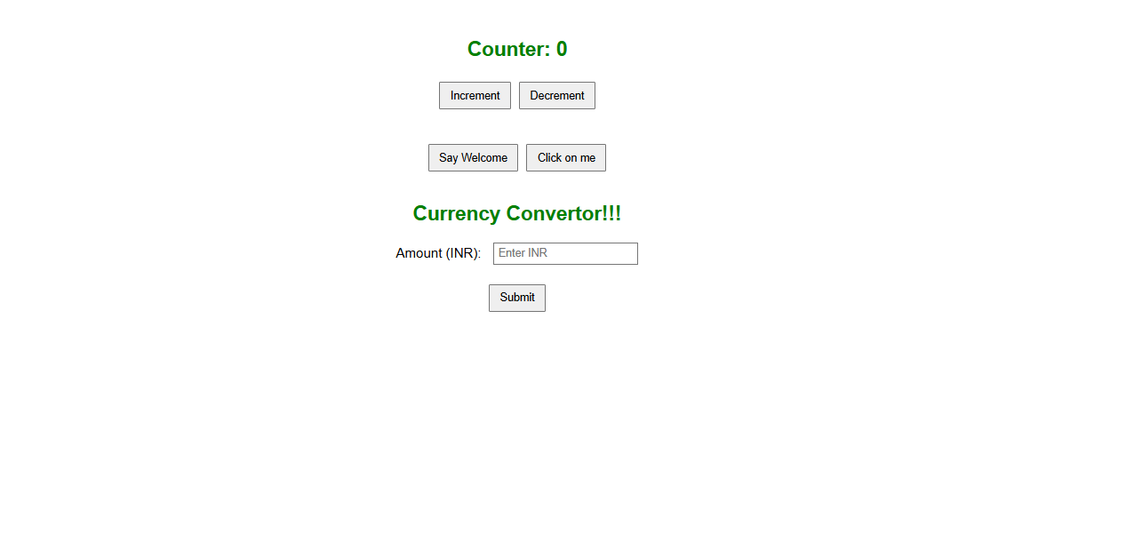

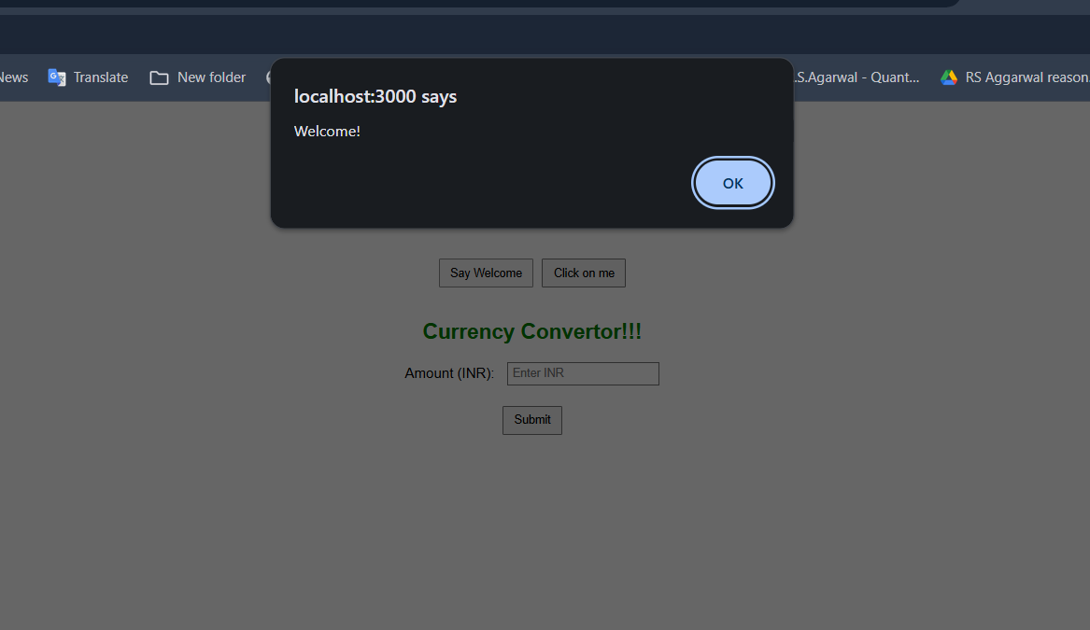

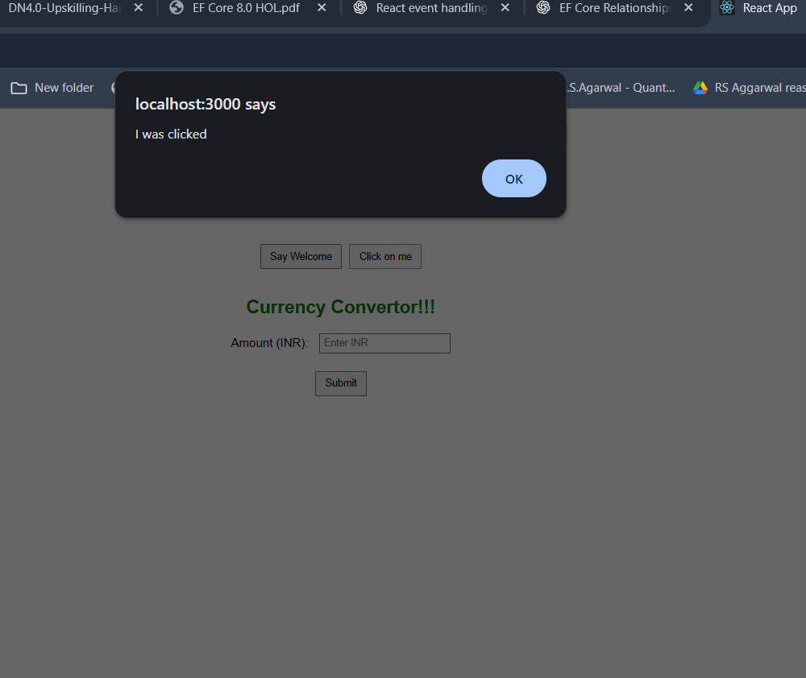

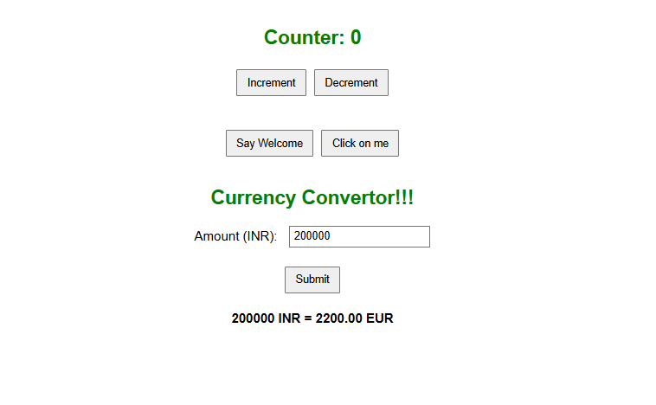

**Counter Incremented to 6 using button**

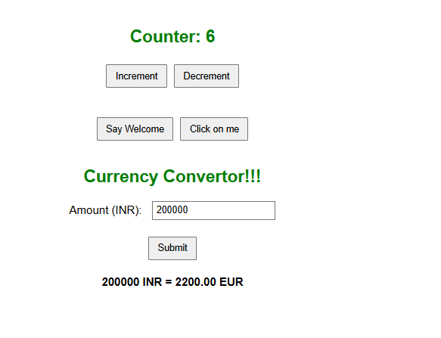

**Counter decrement to 4 using decrement button :**

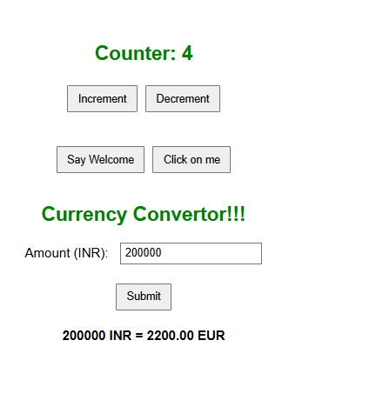

**ASSIGNMENT 12**

**Creating the react app for ticket booking**

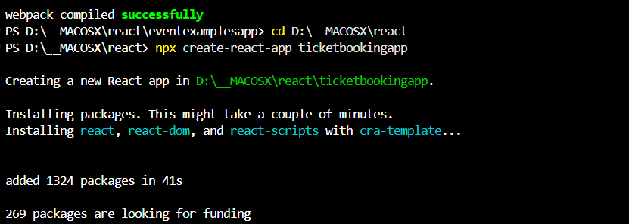

**Working Directory :**

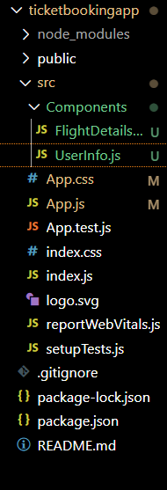

**APP.JS CODE :**

*import React, { useState } from 'react';*

*import './App.css';*

*import FlightDetailsPage from './Components/FlightDetailsPage';*

*import UserInfo from './Components/UserInfo';*

*function App() {*

*const [isLoggedIn, setIsLoggedIn] = useState(false);*

*const user = {*

*name: 'Barath S.',*

*email: 'barath@example.com',*

*};*

*const handleLogin = () => setIsLoggedIn(true);*

*const handleLogout = () => setIsLoggedIn(false);*

*return (*

*<div className="App">*

*<h1>Ticket Booking App</h1>*

*{isLoggedIn ? (*

*<>*

*<button onClick={handleLogout}>Logout</button>*

*<UserInfo user={user} />*

*<FlightDetailsPage />*

*</>*

*) : (*

*<>*

*<button onClick={handleLogin}>Login</button>*

*<p>Please log in to view available flights.</p>*

*</>*

*)}*

*</div>*

*);*

*}*

*export default App;*

**APP.CSS CODE**

*.App {*

*text-align: center;*

*padding: 2rem;*

*font-family: Arial, sans-serif;*

*}*

*button {*

*padding: 10px 15px;*

*margin: 10px;*

*font-size: 16px;*

*cursor: pointer;*

*}*

*table {*

*margin: 20px auto;*

*border-collapse: collapse;*

*width: 80%;*

*}*

*th, td {*

*padding: 10px;*

*border: 1px solid #ddd;*

*}*

*.user-info {*

*margin: 20px;*

*text-align: left;*

*display: inline-block;*

*}*

**CREATE COMPONENTS FOLDER :**

**FLIGHTDETAILS.JS**

*import React from 'react';*

*const flights = [*

*{ id: 1, airline: 'IndiGo', from: 'Chennai', to: 'Delhi', time: '10:00 AM', price: '₹4500' },*

*{ id: 2, airline: 'Air India', from: 'Mumbai', to: 'Bangalore', time: '1:30 PM', price: '₹5200' },*

*{ id: 3, airline: 'SpiceJet', from: 'Hyderabad', to: 'Kolkata', time: '6:45 PM', price: '₹4800' },*

*{ id: 4, airline: 'Emirates', from: 'Hyderabad', to: 'Joneshburg', time: '6:45 PM', price: '₹430000' },*

*{ id: 7, airline: 'Luftansa', from: 'Hyderabad', to: 'London,Oval', time: '6:45 PM', price: '₹400000' },*

*];*

*function FlightDetailsPage() {*

*return (*

*<div className="flight-details">*

*<h2>Available Flights</h2>*

*<table border="1" cellPadding="10">*

*<thead>*

*<tr>*

*<th>ID</th>*

*<th>Airline</th>*

*<th>From</th>*

*<th>To</th>*

*<th>Time</th>*

*<th>Price</th>*

*</tr>*

*</thead>*

*<tbody>*

*{flights.map((flight) => (*

*<tr key={flight.id}>*

*<td>{flight.id}</td>*

*<td>{flight.airline}</td>*

*<td>{flight.from}</td>*

*<td>{flight.to}</td>*

*<td>{flight.time}</td>*

*<td>{flight.price}</td>*

*</tr>*

*))}*

*</tbody>*

*</table>*

*</div>*

*);*

*}*

*export default FlightDetailsPage;*

**USERINFO.JS**

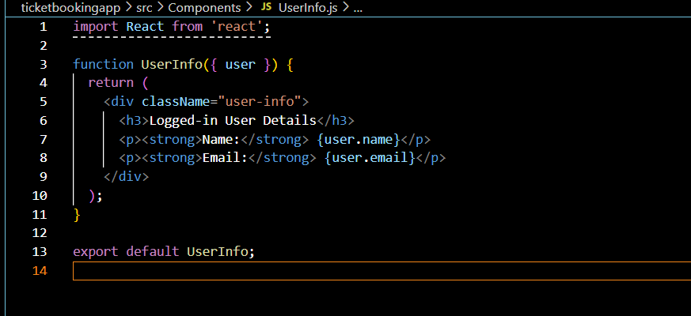

**OUTPUT :**

**Guest Page :**

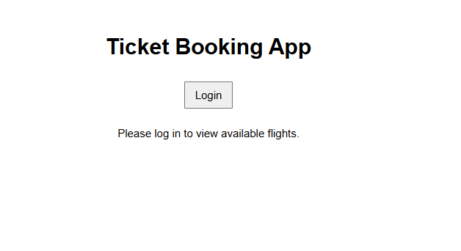

**User Login Page :**

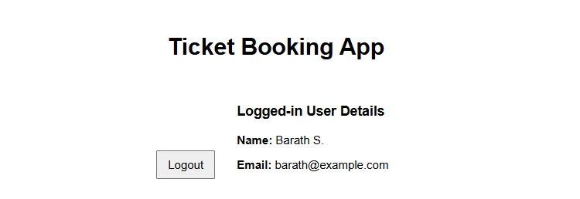

**Flight details display in customer page :**

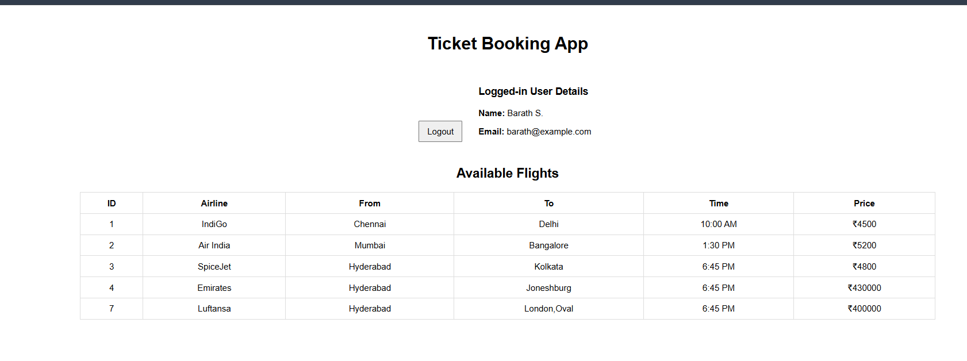

**ASSIGNMENT – 13**

**Creating the react app**

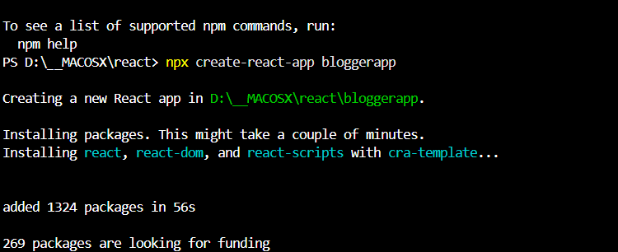

**Working directory :**

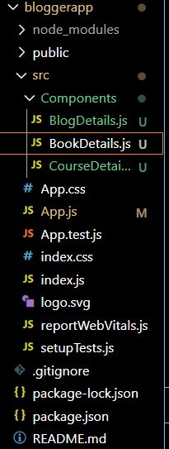

**APP.JS CODE :**

*import React from 'react';*

*import './App.css';*

*function App() {*

*const bookdet = (*

*<ul>*

*{books.map(book => (*

*<li key={book.id}>*

*<strong>{book.bname}</strong> - ₹{book.price}*

*</li>*

*))}*

*</ul>*

*);*

*const content = (*

*<div>*

*<p>Welcome to our programming blog! Here you'll find tutorials on React, Angular, and MongoDB.</p>*

*<p>New articles are posted every week covering the latest web development technologies.</p>*

*</div>*

*);*

*const coursedet = (*

*<ul>*

*{courses.map(course => (*

*<li key={course.id}>*

*<strong>{course.cname}</strong> - {course.duration} hours ({course.level})*

*</li>*

*))}*

*</ul>*

*);*

*return (*

*<div className="container">*

*<div className="st2">*

*<h1>Book Details</h1>*

*{bookdet}*

*</div>*

*<div className="v1">*

*<h1>Blog Details</h1>*

*{content}*

*</div>*

*<div className="mystyle1">*

*<h1>Course Details</h1>*

*{coursedet}*

*</div>*

*</div>*

*);*

*}*

*export const books = [*

*{id: 101, bname: 'Master React', price: 670},*

*{id: 102, bname: 'Deep Dive into Angular 11', price: 800},*

*{id: 103, bname: 'Mongo Essentials', price: 450},*

*{id: 104, bname: 'JavaScript: The Good Parts', price: 550},*

*{id: 105, bname: 'Clean Code', price: 720},*

*{id: 106, bname: 'Design Patterns', price: 890},*

*{id: 107, bname: 'TypeScript Handbook', price: 620},*

*{id: 108, bname: 'Node.js in Action', price: 780},*

*{id: 109, bname: 'Python Crash Course', price: 590},*

*{id: 110, bname: 'Data Structures and Algorithms', price: 950}*

*];*

*export const courses = [*

*{id: 201, cname: 'React Fundamentals', duration: 15, level: 'Beginner'},*

*{id: 202, cname: 'Advanced Angular', duration: 20, level: 'Intermediate'},*

*{id: 203, cname: 'MongoDB for Developers', duration: 10, level: 'Beginner'},*

*{id: 204, cname: 'Full Stack Development', duration: 30, level: 'Advanced'}*

*];*

*export default App;*

**APP.CSS**

*.container {*

*display: flex;*

*flex-wrap: wrap;*

*gap: 20px;*

*padding: 20px;*

*font-family: Arial, sans-serif;*

*}*

*.st2, .v1, .mystyle1 {*

*flex: 1;*

*min-width: 300px;*

*padding: 20px;*

*border-radius: 8px;*

*box-shadow: 0 2px 5px rgba(0,0,0,0.1);*

*}*

*.st2 {*

*background-color: #f0f8ff;*

*}*

*.v1 {*

*background-color: #fff0f5;*

*}*

*.mystyle1 {*

*background-color: #f0fff0;*

*}*

*h1 {*

*color: #333;*

*border-bottom: 2px solid #666;*

*padding-bottom: 10px;*

*}*

*ul {*

*list-style-type: none;*

*padding: 0;*

*}*

*li {*

*padding: 8px 0;*

*border-bottom: 1px solid #eee;*

*}*

*strong {*

*color: #2c3e50;*

*}*

**OUTPUT :**

